Microsoft Power BI Project: Business Performance & Workforce Analytics Dashboard

Business Performance Summary
1. Revenue and Profit Trends
- Revenue establishes that there is steady growth with seasonal peaks. This is predominantly determined by corporate customers in the East and North regions.
- Profit limits are mostly stable but can be impacted by occasional high discounts.
2. Top Products and Categories
- The product with the highest revenue and profit in general is Furniture.
- This can be seen by a range of products with varying cost prices.
- Office Supplies and Accessories have a steady growth but with lower profit margins ((profit/revenue) *100).
- There is a consistent increase in sales for Electronics with a lower volume.
3. Sales Workforce Effectiveness
- Sales output appears to be relatively balanced,
- Revenue per employee can be improved by focussing actions to areas where sales demand can be rapidly increased and there is a higher demand in a specific type of customer.
- For example, you can aim sales in the east region with corporate customers. Where sales appear to be higher.
- Alternatively, the opposite can be said and the data highlights regions and customers where sales are the lowest and this presents the opportunity to promote sales more.
4. Risks and Opportunities
- Risks:
- The more discounts the company is providing the lower the overall profit margin will be.
- This means there is a greater dependency on specific customers and regions to maintain the profit margin.
- So, the company is relying on corporate customers and customers in the eastern region.
- Therefore, if corporate customers stop buying products from the company (for example, by using another supplier) or if there is a decrease in sales within the eastern region, the total revenue for the company will significantly decrease and cause loss. This highlights the need to diversify.

- Opportunities:
- There is an opportunity to grow sales in areas that are underperforming.
- For example, you can identify the region that is selling the lowest amount of furniture and focus marketing toward pushing more promotional offers or increasing the inventory of products for greater sales.
- You can also increase the retention of current customers by targeting marketing strategies.
- This can be by sending more personalised offers and promotions to existing customers linked to the products they have purchased in the past.
- Sales efficiency can also be increased by looking into the alignment of the workforce. This can be by making sure staff are organised more efficiently, assigned to the appropriate areas and are focused in the correct areas to ensure business goals are met.
- For example, the sales team can be strategically assigned to high-value regions and customers for more efficient sales.

Tables:
Customer Table:
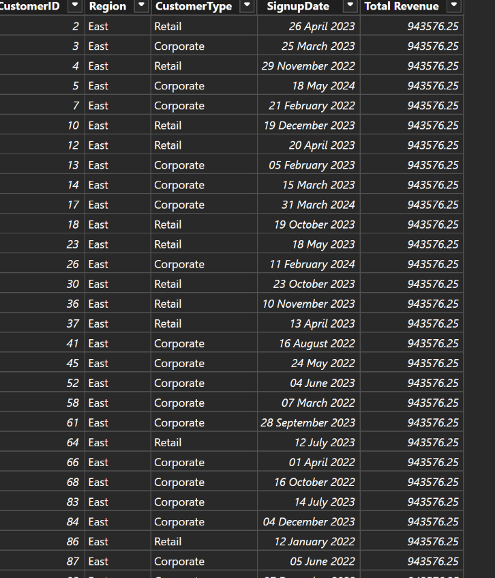

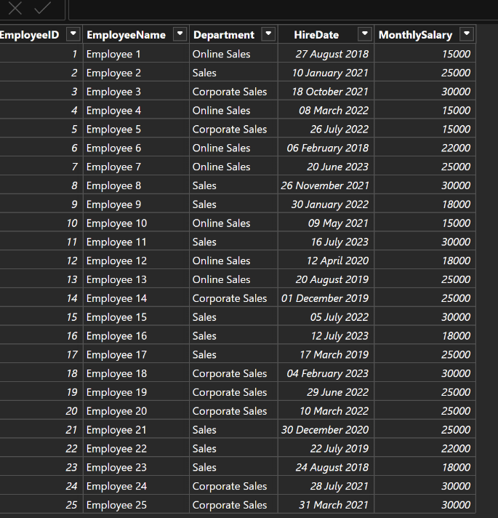
Employees Table:

Products Table:
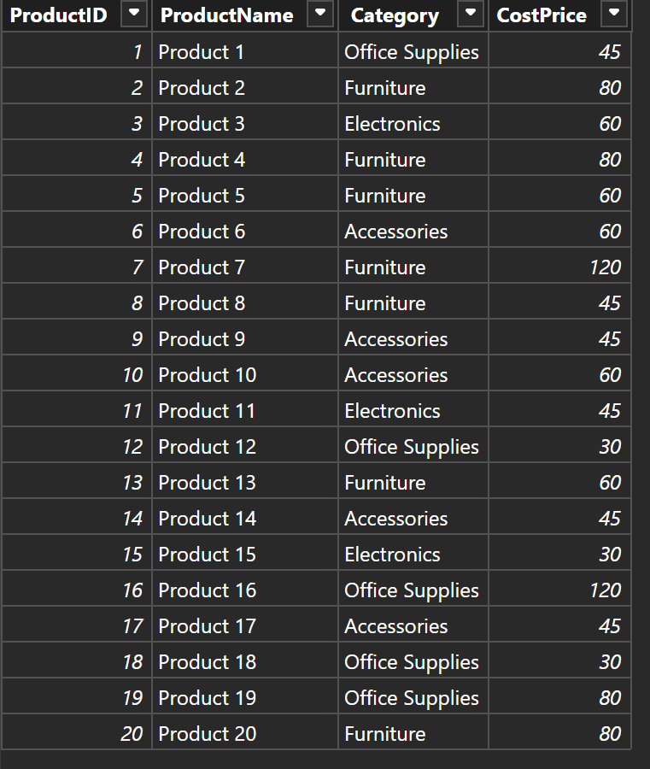

Sales Table:
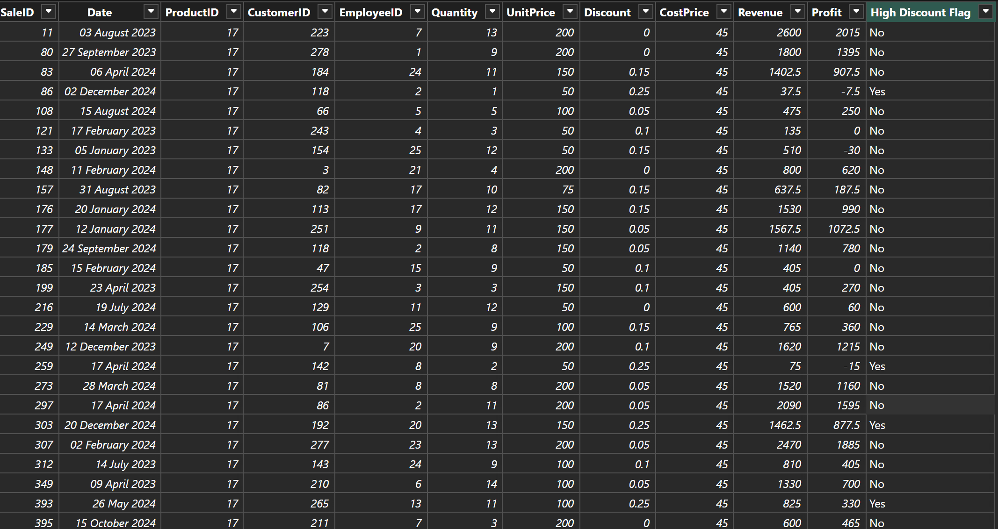

Calendar Table:
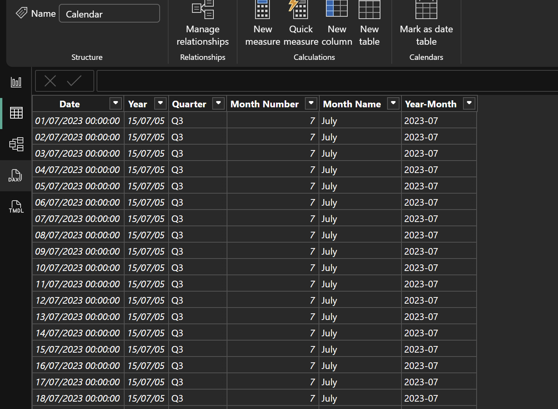

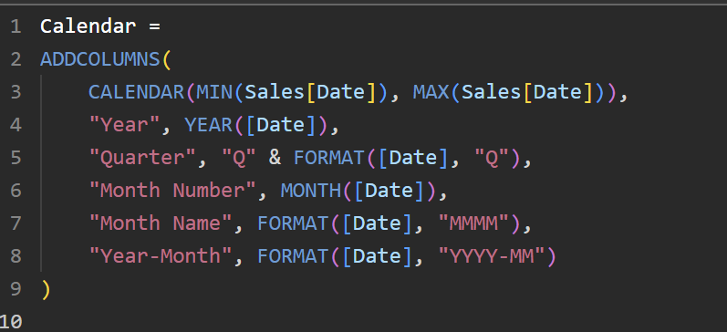
Syntax:

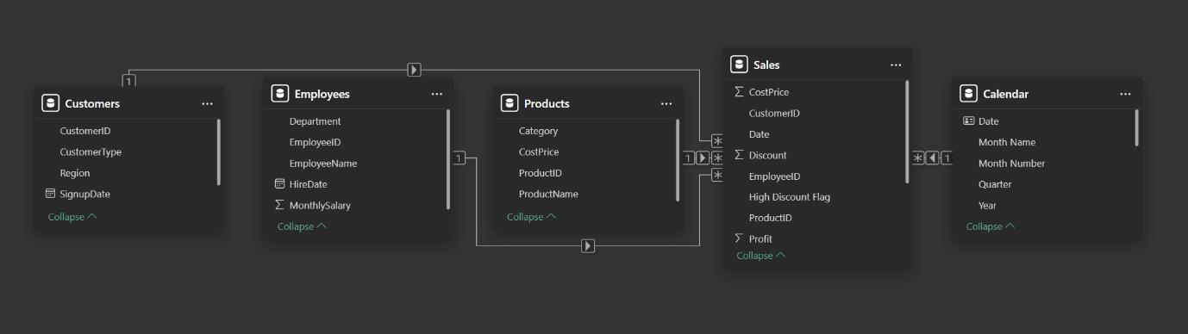
Model View:

Executive Overview:
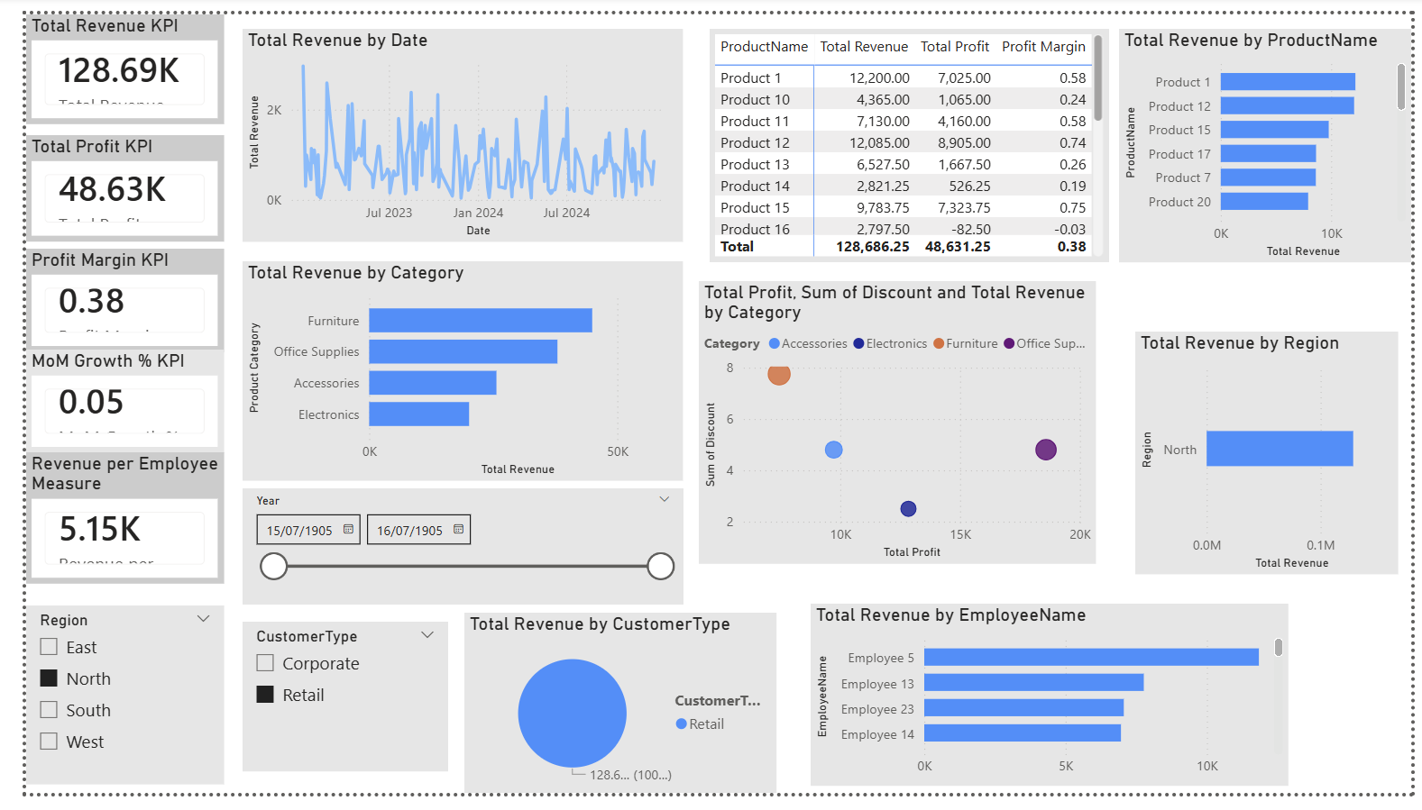
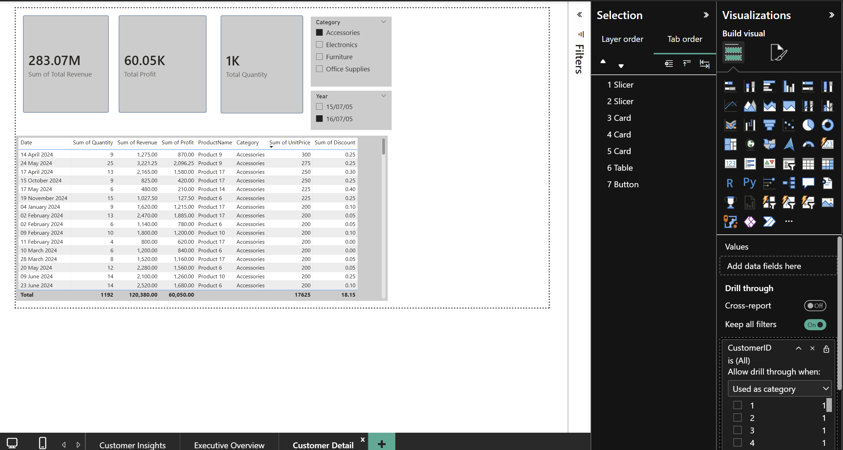
Customer Detail and Drill Through:


